Moore Machines vs Mealy Machines

| Aspect | Moore Machines | Mealy Machines |
| --- | --- | --- |
| Output | Outputs depend only on the current state. | Outputs depend on the current state and input. |
| Number of States | Tends to require more states due to separate output behavior. | Might require fewer states as outputs are tied to transitions. |
| Response Time | Slower response to input changes as outputs update on state changes. | Faster response to input changes due to immediate output updates. |
| Complexity | Can be simpler due to separation of output behavior. | Can be more complex due to combined state-input cases. |

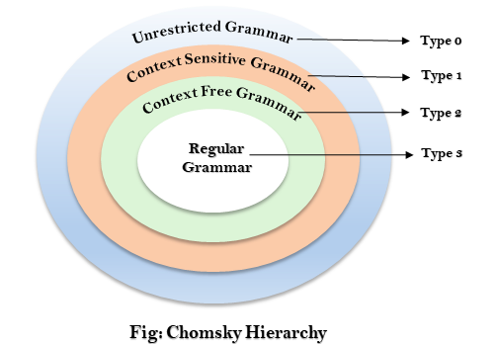

Classification of Languages Based on Recognition

| Type | Language Name | Grammar Name | Recognized By |
| --- | --- | --- | --- |
| Type 0 | Recursively Enumerable | Unrestricted Grammar | Turing Machine |
| Type 1 | Context-Sensitive | Context-Sensitive Grammar | Linear Bounded Automaton |
| Type 2 | Context-Free | Context-Free Grammar | Pushdown Automaton |
| Type 3 | Regular | Regular Grammar | Finite Automaton |

